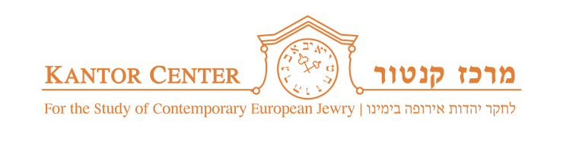




"For You Yourselves Were Strangers in the Land of Egypt" (Exodus, 22:12):

Conference marking World Refugee Day and the Launch of
"Legislating for Equality, Volume III: Africa"

On 14-15 June 2017, at Tel Aviv University

DRAFT AGENDA

Opening Ceremony 17:00-20:30, Wednesday, 14 June 2017, Kes Hamishpat Auditorium, Buchmann Faculty of Law, Tel Aviv University

17:00 – 17:15 Greetings: The Honourable Mr. Elyakim Rubinstein, Israeli Supreme Court Justice

17:15 – 18:00 Key Note Lecture: Prof. Yoram Dinstein

18:00 – 20:00 Session 1: Europe, Migrants and Refugees

Chairperson: Prof. Dina Porat, Head of the Kantor Center

Speakers: H.E. Clemens von Goetze, Ambassador of Germany to Israel

H.E. Francesco M. Talò, Ambassador of Italy to Israel

Dr. Reuven (Ruvi) Ziegler, Lecturer in Law at the University of Reading

Second Conference Day 9:30 – 17:30, Thursday, 15 June 2017, Beit Hatfutsot, Zeevi Auditorium

9:30 – 11:30 Session 2: International Refugee Law and Humanitarian Law

Chairperson: Dr. Yuval Livnat, Academic Supervisor of Refugee Rights Clinic, Tel Aviv University

Speakers: Mr. Leonard Zulu, Head of the Policy and Legal Unit, UNHCR Africa Bureau

Prof. Yuval Shani, Hersch Lauterpacht Chair in International Law at the Law Faculty of the Hebrew University of Jerusalem.

Prof. Tomer Broude, Faculty of Law and Department of International Relations, Academic Director, Minerva Center for Human Rights, Hebrew University of Jerusalem

11:30 – 12:00 Coffee Break

12:00-14:00 Session 3: African Colonial History and Recent Legal Developments

Chairperson: TBC

Speakers: Prof. Galia Sabar, President of Ruppin Academic Center

Dr. Irit Bak, Head of Africa Studies Program, Tel Aviv University

Adv. Talia Naamat, Kantor Center, Tel Aviv University, Co-editor of "Volume III: Africa, Legislating for Equality"

14:00 – 15:30 Lunch

15:30-17:30 Session 4 - In memory of Yizhak Arzi Z"L

Israel, Asylum Seekers and Refugees

Chairperson: Adv. Anat Ben-Dor, Refugee Rights Clinic, Tel Aviv University

Speakers:
Mr. Meir Shitrit, Former Israeli Minister of Justice

Adv. Assaf Weizen, Aid Organization for Refugees

Mr. Mutasim Ali, Academic College of Law & Business, Ramat Gan

